Languages, Literacy and Communication  I will:  - Read the book Here We Are by Oliver Jeffers  - Write about my house  - Write about Canton  - Investigate features of leaflets  - Design my own leaflet about Canton  - Practise and consolidate learning of letters and sounds through Monster Phonics  I can:  - Understand information about a variety of topics, identifying main points.  - Find and use information from different materials that I read.  - Respond to what I hear, read and see, asking questions and showing my understanding.  - Use my imagination to create my own literature. | Mathematics and Numeracy  Y1 I will:  Learn about place value  - Sort, count and represent objects  - Recognise numbers as words  - Count on from any number  - Calculate 1 more/ less  - Count backwards within 10  Practise addition and subtraction  - Fact families addition facts  - Number bonds within 10  - Addition and subtraction problems  Recognise and name 2D and 3D shapes  Y2 I will:  Learn about place value  - Count within 100  - Recognise tens and ones  - Partition numbers to 100  - Compare/ order numbers  - Count in 2s, 5s and 10s  Practise addition and subtraction  - Fact families addition facts  - Number bonds to 100  - Addition and subtraction problems  Recognise and name 2D and 3D shapes including sides, vertices and lines of symmetry.  I can:  - Understand that the value of a number can be determined by the position of the digits.  - Read, write and interpret numbers using digits and words.  - Explore 2D and 3D shapes and their properties in a range of contexts |  | Health and Wellbeing  I will:  - Learn about and use the Zones of Regulation and talk about how I am feeling  - Learn our class and school rules and understand that they are there to keep me safe  - Practise sharing and taking turns when playing and working with others  - Listen to and follow instructions when working and playing  - Celebrate our similarities and differences during aWellbeing Week  I can:  - Acknowledge that rules are there to help me stay safe, I should follow them without prompt  - Show patience and support for others
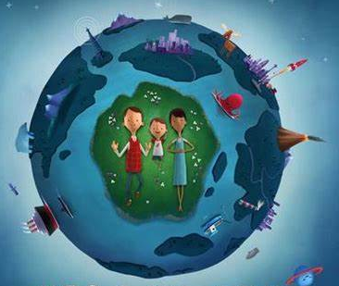
Here We Are – Dyma Ni.
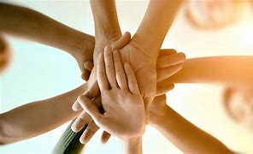
This term our learning across the curriculum will focus on our identities - who we are and where we live. We will explore the local area around our school and learn about Canton. We will discover, learn and develop our sense of belonging through working and playing in the classroom and outdoors.
Science and Technology  I will:  - Look at the similarities and differences between our homes  - Investigate materials homes are made from and their properties  - Design and make a model house using recycled materials  I can:  - Understand that properties of materials are different  - Change and adapt my plans | Expressive Arts  I will:  - Create a self portrait using pencils and pastels  - Create two pictures of the same place at different times of the day (as shown in story)  - Design a model house  - Create 2 portraits to convey different emotions happy/sad. Use colours linked to the emotion  - Create a dance using different music to convey a variety of moods  - Ocean art using watercolours  I can:  - Use creative techniques to communicate mood and feelings  - Use my imagination to recreate  - Evaluate my own and others work  - Use different colours, shapes, textures,senses and tools |  | Humanities  I will:  - Talk about and identify where my school is and where I live  - Learn about similarities and differences between our homes  - Visit local area then draw a simple map  - Find out about different festivals and religions that are celebrated eg Diwali and Christmas  - Visit a local place of worship  I can:  - Use mapping skills to allow me to find my way around  - Understand that places, spaces, environments and landscapes are important to different people and for different reasons  - Understand that other people may have different opinions/ beliefs  - Understand that the world around me can affect my health  - Understand that my community is made up of people who have differences and similarities
Learning Experiences and or Visitors |  | Community/Focus Weeks/Special Events
- Go on a walk to explore our local area |  | - Global Diversity month - Sept/Oct  - Hello Yellow Day and Wellbeing Week  - Harvest  - Diwali - Nov 1st  - Bonfire Night - Nov 5th  - Christmas

