Languages, Literacy and Communication  I will:  - Read the book Here we are by Oliver Jeffers  - Write about our wonderful world  - Identify features of a postcard  - Understand different tenses - past, present and future  - Write my own postcard from Cardiff  - Practise and consolidate learning of letters and sounds through Monster Phonics  - Develop my handwriting skills and presentation of my work  - Create a leaflet on Cardiff  - Write imaginatively about the animals on the castle wall  - Talk about the weather in Welsh and what I will be able to do and wear  I can :  ● Understand information about a variety of topics, identifying main points.  - Find and use information from different materials that I read.  - ● Respond to what I hear, read and see, asking questions and showing my understanding.  - ● Use my imagination to create my own literature. | Mathematics and Numeracy  PLACE VALUE  I will:  - Count objects to 100 by making 10s  - Recognise Tens and Ones  - Use a place value chart  - Partition numbers  - Write numbers in words  - Estimate numbers on a number line  - Count in 2s, 5s 10s and 3s  Yr 3 - AS above and also  - HTU  - Representing numbers to 1000  - Find 1, 10 or 100 more  - Count in 50s  ADDITION AND SUBTRACTION  I will  - use my bonds to 10/100  - Use fact families  - Add and subtract 1/10/100  - Add 3 1 digit numbers  - Add to the next 10  - Understand missing number problems  Yr 3 - As above plus  - add 2 digit and 3 digit numbers  - Estimate  - Understand the inverse  - Spott patterns  TIMES TABLES AND DIVISION -Yr3  - Times table and division for 2,5,10,3,4 and 8 facts  - Using arrays to show facts  I can:  ● Understand that the value of a number can be determined by the position of the digits.  ● Read, write and interpret numbers using digits and words.  - Explore 2D and 3D shapes and their properties in a range of contexts |  | Health and Wellbeing  I will:  - Learn about and use the Zones of Regulation and talk about how I am feeling  - Learn our class and school rules and values and understand that they are there to keep me safe  - Practise working cooperatively with others  - Listen to and follow instructions  - Celebrate our similarities and differences  - Join in with developing football skills with CCFC  - Take part in physical activities such as dance and gym  I can:  - Acknowledge that rules are there to help me stay safe, I should follow them without prompt  - Show patience and support for others
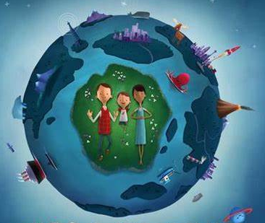
Here We Are – Dyma Ni.

This term our learning across the curriculum will focus on our city of Cardiff. We will be looking at our identity and what makes Cardiff special to us. We will be thinking of our cynefin
Science and Technology  I will:  ● Look at the similarities and differences between castles in Cardiff Castle  ● Investigate materials castles are made from and their properties  ● Design and make a model castle using recycled materials  I can:  ● can explore and describe the properties of materials and justify their uses.  ● make design decisions, using my knowledge of materials and existing products, and suggest design improvements. | Expressive Arts  I will:  - help create a class song  - Sing a range of songs  - Move to music creatively  - Produce artwork of Cardiff Castle  I can:  ● Use creative techniques to communicate mood and feelings  ● Use my imagination to recreate  ● Evaluate my own and others work  Use different colours, shapes, textures,senses and tools |  | Humanities  I will:  - use maps to locate Cardiff  - Discuss landmarks of Cardiff  - Understand what makes a city  - Find out information and the history of Cardiff castle  - Explore places of worship in Cardiff  - Understand Cynefin  I can:  - Use mapping skills to allow me to find my way around  - Understand that places, spaces, environments and landscapes are important to different people and for different reasons  - Understand that other people may have different opinions/ beliefs  - Understand that the world around me can affect my health  Understand that my community is made up of people who have differences and similarities
Learning Experiences and or Visitors |  | Community/Focus Weeks/Special Events
Visit Cardiff Castle

