Languages, Literacy and Communication  I will:  - write a story  - explore biographies  - participate in drama activities  - write an interview  - write about a hero in my life  - write a simple script  - learn and perform Welsh songs  - Daily Monster Phonics  - Write a circular story  I can :  - I can find and use information from different materials that I read.  - I can listen to others and understand that they may have a different perspective from my own  - I can speak clearly, varying expression and gestures to communicate my ideas.  - I can explain information and share ideas, opinions and feelings using relevant vocabulary.  - I can retell stories creatively.  - I can write in various styles | Mathematics and Numeracy  I will:  - use arrays to show multiplication facts  - learn x2, x5 and x10  - and the related division facts  - Counting money - pounds and pence  - Making amounts of money  - Add and subtract money  - Find change  - Draw, sort and describe 2d and 3d shapes  I will (Year 3)  - x3, x4 and x8  - multiply a digit number by 1 digit with and without an exchange  - divide a 2 digit number by a 1 digit number with remainders  - Turns and angles  I can:  - Calculate mathematical statements for multiplication and division within the multiplication tables and write them using the multiplication (×), division (÷) and equals (=) signs  - Recognise angles as a property of shape or a description of a turn  - Recognise and use symbols for pounds (£) and pence (p); combine amounts to make a particular value  - Solve simple problems in a practical context involving addition and subtraction of money of the same unit, including giving change |  | Health and Wellbeing  I will:  - Gain an understanding of how Aneurin Bevan was a very important person in the early creation of the NHS
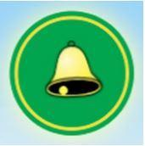
Radnor’s Got Talent - Heritage Heroes
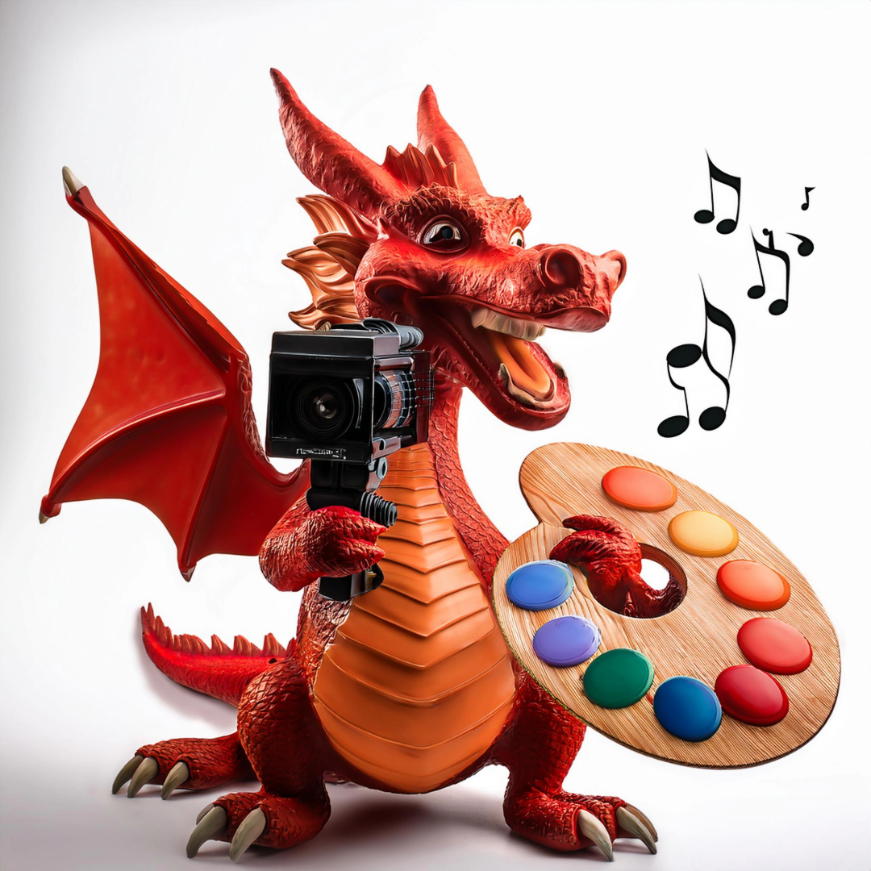
This term within our learning across the curriculum we will be looking through the lens of Cynefin and community with a particular focus on ‘Expressive Arts’ and ‘Humanities’. The concepts we will cover are culture, performance and communication through the lens of art and drama.

Under the topic of Heritage Heroes we will focus on the following questions
Who is our patron saint? Who should be? We will explore key figures from Wales past and present and find out about their lives. We will also explore the work of Welsh artists and will create our own piece of art in the same style.
All of our learning will culminate in a showcase for our school Eisteddfod where we will deliver a drama performance and share our learning of who we consider to be a Welsh hero.

Expressive Arts

I will:
- role play the story of a famous Welsh person
- perform on stage and to camera, telling the story of our chosen Welsh personalities
- learn a song by a Welsh singer and perform to an audience
- create art based on the work of a Welsh artist

I can:
- explore and experiment with and then select appropriate creative techniques, practices, materials, processes, resources, tools and technologies
- perform, produce, design, exhibit and share my work in a variety of ways for different audiences

Humanities

I will:
- I will find out about our patron saint - St David
- I will explore Welsh heroes in that past and the present and how their lives have made a positive impact on Wales.
- I will express my opinions on who I think could be considered aWelsh hero
- I will present my findings in a collaborative, informative and creative performance for an audience.

I can:
- I can present what I have discovered in a variety of ways and draw simple conclusions.
- I can form and express opinions about something that is important to me, considering my own ideas, feelings and those of others.
- I can recognise similarities and differences between people’s lives, both in the past and present.
- I can recognise that my actions and those of others impact upon communities and the environment

Science and Technology

I will:
- Use a variety of technology to record performances
- Use the internet safely to carry out research about Welsh heroes
I can:
- I can safely use a range of tools, materials and equipment to construct for a variety of reasons.
- I can follow instructions to build and control a physical device.
- I can experiment with and identify uses of a range of computing technology in the world around me.

Learning Experiences and or Visitors |  | Community/Focus Weeks/Special Events
- National Handwriting Day (23 Jan)
- Saint Dwynwen’s Day (25 Jan)
- Chinese New Year (29th Jan)
- National Storytelling Week (30 Jan - 6 Feb )
- Internet safety day (11 Feb)
- Eisteddfod (20 Feb )
- Ramadan (28 Feb)

