Languages, Literacy and Communication  I will:  - Read and enjoy the book Rosie Revere Engineer  - Learn the features of an explanation text  - Use bossy verbs  - Use the apostrophe to show possession  - Continue work on noun phrases and conjunctions  - Write my own explanation text  I can:  - I can use single and multi-clause sentences  - I can use my knowledge of letter sounds and patterns accurately in my spelling.  - I can explain information and share ideas, opinions and feelings using relevant vocabulary.  - I can write using an increasingly imaginative, varied and precise vocabulary.  - I can organise my writing into a logical sequence. | Mathematics and Numeracy  I will:  - Add and subtract fractions  - Add and subtract money  - Convert pounds and pence and give change  - Use time- digital and analogue  - Recognise and describe 2D and 3D shapes  - Pictograms and bar charts  I can:  - Explore equivalent fractions and add and subtract fractions and  - Understand the equivalence and value of coins and notes  - read digital and analogue clocks accurately  - Explore and consolidate my understanding of 2D and 3D shapes  - Collect and organise data and record and represent data ina variety of ways | Health and Wellbeing  I will:  - Practise skills for sports day  - Take part in a range of athletic activities  I can:  Recognise some of the behaviours, conditions and situations that affect my physical health and wellbeing and know how to respond and get help in a safe way.  - Use and improve basic movement skills in familiar and unfamiliar situations.  - Respond to prompts in imaginative and creative ways.  - Have the confidence and motivation to persevere when faced with physical challenges.  -
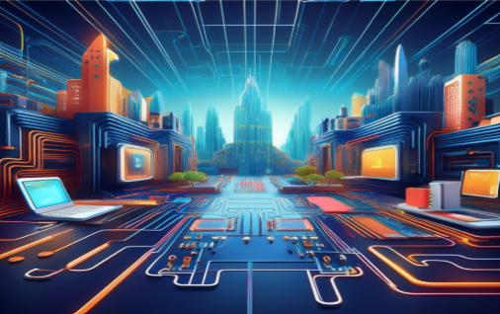
Building with Bytes
This term our learning across the curriculum will focus on our technology. Through one of our 5 lenses; ‘Technology’ this topic will focus on using Science and Technology to solve a problem in our school.
Our Big Question is: Can we use Scratch to create a book?

Science and Technology
I will:
- use Scratch to create a character
- create a game using various levels
- Code your projects using sprites, scripts and loop
- Use skills learnt to create a book

I can:
- create simple algorithms
- use loops to make my algorithms more precise

Humanities
- Technology is used for different purposes.
- Learning about technology will help me get better at using it.
- Technology can solve problems.
- Technology can help me find answers.

Learning Experiences and or Visitors
To showcase our final project to Miss Wainwright

