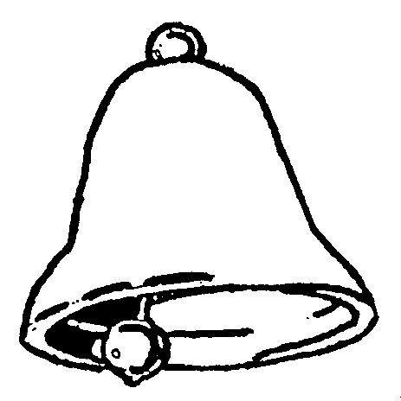

,

Teaching and Learning Policy

Written in Consultation with Staff and Governors

Autumn Term 2022

Review Date
Autumn Term 2023

Introduction
At Radnor Primary School we believe in the concept of lifelong learning, and relish and celebrate the notion that both adults and children learn new things every day and grow as a result of this learning. We strive to ensure that learning is a rewarding, challenging, progressive and enjoyable experience for everyone and meets the needs of our children. Through our teaching, we believe that we equip children with the skills, knowledge and understanding necessary to be able to make informed choices in their lives. We believe that appropriate teaching and learning experiences help children to lead happy, fulfilling and rewarding lives.

Aims
We recognise that most individuals learn in different ways so we aim to provide a rich and varied learning environment that allows all of us to develop our skills and abilities both now and in the future. Through our teaching, we strive to ensure that children:

- Experience excitement in learning, enjoy it and build a positive attitude towards lifelong learning
- Are treated with respect
- Have the best possible basis for future growth and development
- Have access to a range of learning opportunities and improve knowledge and understanding
- Develop thinking skills, questioning, planning, problem solving, creative and critical skills
- Are involved in the assessment of their own work and are aware of the next steps in their learning
- Are given opportunities to work independently and collaboratively
- Enjoy the best possible physical, mental, social and emotional health
- Have access to play, leisure, sporting and cultural activities
- Learn to experience failure and use this as a platform to build on
- Develop an understanding of their spiritual, moral and cultural awareness and that of the wider community

Learning and Teaching Cycle
At Radnor we have developed our own Learning and Teaching Cycle that reflects the way that our children learn best and that we teach most effectively. It is on display in every classroom.

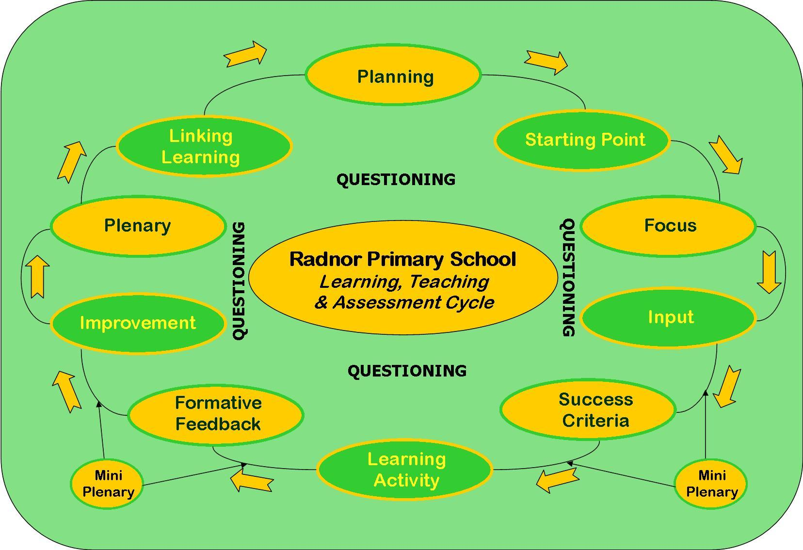

At Radnor we believe that Assessment for Learning and Thinking Skills are central to the way our children learn and our teachers teach.

Assessment for Learning
Assessment for Learning exists to help the teacher to help the child and the children to help themselves and each other to become more independent in their learning. It ensures more effective teaching by providing the evidence for closer matching of tasks to the children’s needs. It assists the children by providing them with an indication of what stage they have reached in their learning process and it helps to identify future planning and learning and teaching strategies.

Assessment for Learning:
- Is central to classroom practice
- Is a tool for all regardless of age or ability
- Is part of effective planning
- Focuses on how children learn
- Has an emotional impact by promoting self-esteem and motivation
- Promotes commitment to learning objectives and success criteria
- Helps learners evaluate their learning and know how to improve
- Encourages self and peer-assessment
- Recognises progress from child’s previous best
- Celebrates success
- Encourages active participation in learning
- Facilitates the setting of short-term and long-term goals

We use these strategies to link assessment to better learning and teaching:
- Evaluation of lessons informs the next plan
- Focussed use of data from formal assessment to inform planning and grouping
- Clear focus and success criteria
- Focused marking using feed forward comments
- Self and peer-assessment
- Individual pupil targets

Thinking Maps
Thinking Maps provide common, consistent visual patterns for working on complex ideas and situations.

RUCSAC
This is a framework for problem solving in maths which requires learners to go through set steps in solving number problems. The steps are:
- Read
- Understand/Underline
- Choose the mathematical operation(s) to use
- Solve the problem
- Answer the question
- Check your answer

TASC
This is a framework for carrying out an enquiry. It takes the form of a wheel with prompts for each stage of the process. It can either be used in its entirety or different sections can be focussed on. See Appendix 2 for the format.

No Hands Up/Talking Partners
At Radnor we understand that all children need to be engaged in the thinking and learning process. We therefore have a policy of asking for input from the children at random, without hands up. Children know that if a question is asked or comment/feedback is required there is always a chance that they will be required to comment. This leads to increased concentration and participation. Lollipop sticks are used to pick who will respond. Children understand that whilst a response is expected, they have the option of passing on answering the question.
It also helps the learning process to discuss questions with others and so at Radnor we have a policy of encouraging talking with a partner, following the Think-Pair-Share model.

Questioning
At Radnor we understand the value of asking and encouraging rich, open questions so that they lead to deeper thinking. We have adopted the Pose-Pause-Pounce-Bounce model:
POSE - The teacher (or a child) will firstly set a question.
PAUSE - Children will be given time to think (individually/paired/in a group).
POUNCE - a child/pair/group will be chosen at random to respond to the question.
BOUNCE – another child/pair/group will be chosen at random to comment/respond/
add/sum up and so on.

Assessment of Learning
At Radnor we understand that Assessment of Learning is vital to effective learning and teaching. Details of how we assess learning are contained in our Assessment Policy.

Effective Learning and the Classroom Environment
We recognise seven main areas of intelligence: linguistic, logical/mathematical, visual/spatial, kinaesthetic, musical, interpersonal/group working and interpersonal/ reflective. We include a variety of these approaches in learning experiences throughout the curriculum.

We ensure the best possible environment for learning by developing a positive atmosphere in which pupils feel safe, an environment where challenge is relished and failure viewed as a step in the learning process.

We recognise the importance of a healthy mid-morning snack and access to drinking water.

In order to meet the needs of all learners we offer opportunities for children to learn in different ways. These include:
- Problem solving
- Research and discovery
- Independent work, paired work, group work, whole class work
- Asking and answering questions
- Developing the use of ICT throughout the curriculum
- Fieldwork and visits to places of educational interest
- Creative activities
- Cross curricular studies
- Learning through a variety of media
- Debates, role plays and oral presentations
- Designing and making things
- Participation in physical activity, drama and music
- Reflecting and assessing what has been learned
- Assessment of their own learning and that of their peers

We encourage all children to take responsibility for their own learning. Self assessment and peer assessment strategies are used, as well as mini plenaries and a planned plenary at the end of lessons to assess the children’s level of understanding of the key lesson focus and skills taught. Staff use assessment tools regularly to plan for the next stages of learning and these are shared with the pupils.

Learning takes place in an environment which is:
- Welcoming, stimulating, challenging and supportive
- Calm
- Happy
- Organised
- Well resourced
- Accessible
- Safe
- Encouraging and appreciative

Pupil Voice
In order for children to develop as learners it is vital that they have and feel that they have a say in all aspects of school life. At Radnor we respect the need for the children to have a voice in school and this is encouraged through a variety of different means, including Curriculum Planning and Evaluation and Y Senedd Radnor – our pupil action groups.

Y Senedd Radnor
Y Senedd Radnor consists of a number of pupil action groups. These groups are decided on by the pupils and may change from year to year. They might include groups with responsibility for action on:

- Active travel
- The environment
- Wales and local community relations
- Healthy schools
- Pupil wellbeing
- Children’s rights

Pupil action groups
Each group decides on its own mission statement and a number of targets. They then draw up action plans for the targets and work on those throughout the year. Each group elects a chair and also has a member of staff whose role is to advise and guide.

Effective Teaching
At Radnor Primary School we believe children learn effectively when the teacher provides:
- Relevant, well thought out and well prepared lessons, with appropriate pace
- A shared, skills-based lesson focus giving clear expectations of what pupils are expected to achieve
- Open-ended, thought provoking, challenging questions
- Support for the inclusive learning of all pupils
- Lessons where children’s understanding is developed through active, practical and firsthand experiences, involving individual and collaborative talk exploration, questioning, prediction and investigation
- Lessons where children’s previous learning and interests are built upon
- opportunities to assess, review and reflect on their learning
- Thinking time and discussion time before answering questions
- Developmental feedback and constructive criticism of pupils’ work
- Progressive activities in the light of new initiatives and research.

We follow the Curriculum for Wales.

Links between Planning and Assessment
At Radnor we recognise the direct link between assessment and planning – assessment provides teachers with pupils’ next steps in learning and this information ensures planning and therefore teaching is relevant to the needs of all pupils.

Tracking
At Radnor we use a bespoke tracking tool to monitor the progress of all children in LLC and M&N, as well as tracking their wellbeing. Our tracking system focuses on progress rather than attainment. Individual pupil performance in each of these areas of learning/subjects are recorded and analysed on a termly basis.

Progress Meetings
At the end of each term teachers meet with the Headteacher to discuss the progress of all pupils in their class/set using the tracking spreadsheets. Pupils making more/less than expected progress are identified and actions are agreed. Over the following progress meetings these actions are reviewed and, if needed, amended.

ALN
Teachers make ongoing formal and informal assessments of each child's progress, and they use this information when planning their lessons. It enables them to take into account the abilities and needs of all their children so as to further develop their knowledge and skills. When planning work for children with additional learning needs, we give due regard to information and targets contained in the children's Individual Development Plans (IDPs) and work closely with the ALNCo. Teachers modify teaching and learning as appropriate for children with additional learning needs. We value each child as an individual.

We use teachers and teaching assistants to deliver a range of interventions including ELSA, Talkabout, Rainbow Readers, Rapid Readers, Direct Phonics, SAIL, Handwriting Motorway, Speech Links, Sounds Discovery, Language Links and Catch Up Numeracy. The children are carefully selected for these interventions by the analysis of test data and ongoing teacher assessments and reports. Progress is monitored by the ALNCo and groups are adjusted in line with this monitoring as necessary.

Lesson plans contain information about the skills required, tasks to be set, the resources needed, and take account of English as an Additional Language (EAL) implications, bilingualism and the way in which we assess the children's work.

We deploy teaching assistants and other adult helpers as effectively as possible. They work with individuals or small groups either in the classroom or withdrawing them. We are continually assessing their effectiveness and redeploying where and when necessary.

Cross Curricular Skills Framework

Literacy, numeracy and digital competence are mandatory cross-curricular skills within Curriculum for Wales. The Senior Leadership Team and teaching staff work in teams across all curriculum areas, to develop and ensure progression in these skills.

At Radnor our current curriculum planning has been adapted to support cross curricular planning using the LNF and DCF tasks are set that aim to introduce, consolidate, apply and make progress in specific literacy, numeracy skills and computational skills.

Every term teachers map out specific and regular opportunities for applying skills that have been taught in literacy and numeracy sessions throughout the curriculum in order to ensure consolidation of those skills.

Risk Assessments
We aim to ensure that all tasks and activities that the children perform are safe, whilst opportunities are provided for them to take calculated risks. When we plan to take children out of school, we follow a strict set of procedures to ensure safety: where possible we visit the location, risk assessments are completed and recommended teacher pupil ratios are complied with. We inform parents, and obtain their permission, before a visit takes place and do not take children without signed permission.

Continuing Professional Development
All of our teachers reflect on their strengths and weaknesses, and plan their professional development accordingly. We do all we can to support our teachers in developing their skills, so that they can continually improve their practice.

Professional Dialogue
We understand the need for professional dialogue in order to challenge, support and stimulate teachers and teaching. There is a regular timetable of focussed observation and feedback is given in a supportive manner, highlighting strengths and suggesting ways forward. There is also a system of peer observation in place whereby colleagues are encouraged to visit each others' classrooms in order to observe good practice and stimulate discussion. Teachers are encouraged to film themselves teaching, analyse their teaching style and discuss their findings with colleagues.

Planning
Long term planning follows rolling programmes to allow for mixed year groups. At times, a subject may be taught discretely (where they do not fit into a Context for learning (CfL)). However, opportunities are also taken to incorporate these into our topics wherever possible.

Consistency
At Radnor we recognise that consistency of practice is key to children's learning. Whilst there will be some adjustments for different individuals or groups of learners, planning for classes in the same year group (or across year groups where there are split year classes) is consistent and teachers are expected to team plan in order to ensure consistency, reduce pressure of work and share good practice. Key teaching strategies, for example with regard to Assessment for Learning and Thinking, are agreed by all staff and there is an understanding that they will be used consistently and developmentally across the school. The result is that children have tools and a common framework within which they can learn, knowing that that framework will not change from class to class or year group to year group. Monitoring and observation is used to assess the extent to which these strategies are being used consistently across the school.

The Role of Parents
We believe that parents have a fundamental role to play in helping children to learn. We do all that we can to inform parents about what and how their children are learning by:
- Holding three parents' meetings per year
- Sending an annual written report of children’s progress which includes test results
- Holding information events and sending literature on new initiatives and school practices, for example a literacy and numeracy evening for Reception parents and curriculum events where parents could view and experiment with resources
- Holding curriculum evenings explaining curriculum reform in Wales
- Explaining to parents how they can support their children with homework and suggesting, for example, regular shared reading with very young children, and support for older children with their projects and investigative work
- Encouraging parents to come into school to support a variety of learning experiences within the life of the school

We believe that parents have the responsibility to support their children and the school in implementing school policies. We would therefore ask parents to:
- Ensure that their child has the best attendance record possible
- Ensure that their child is equipped for school with the correct uniform and PE kit
- Do their best to keep their child healthy and fit to attend school
- Inform school if there are matters outside of school that are likely to affect a child's performance or behaviour
- Promote a positive attitude towards school and learning in general
- Fulfil the requirements set out in the home/school agreement
- Provide a healthy mid-morning snack
- Encourage children to complete any home/school tasks.

Display
The school believes that the purpose of display is to support children’s learning. This may be achieved in a variety of ways:
- Engaging pupils in learning – interactive display, asking questions, challenging, success criteria, exciting ideas, fresh, relevant and colourful
- Enabling learning to take place – word lists, number lines, timelines, clocks, place value cards, whiteboards, number squares, times tables, high frequency words, resources
- Keeping what has been learned in mind – key ideas, word lists, rules, lesson focus
- Celebrating success – display work, house points, star of the week, pupils’ photos
- Clarifying routines – use of visual timetables, labelled resources, signs, rules
- Encouraging independence – word banks, class groups, responsibilities, strategies for self-help
- Inclusive classroom – multicultural content, named work by pupils, pupil ownership.

Our classrooms are attractive learning environments. We change displays regularly, so that the classroom reflects the topics studied by the children. Children’s work is displayed in order to celebrate their achievements. Wherever possible, there is Welsh content to display.

All classrooms have a range of dictionaries and fiction and nonfiction books. They also have specific areas dedicated to writing, reading and mathematics. We believe that a stimulating environment sets the climate for learning and that a well resourced and well laid out classroom promotes independence and high quality work by the children.

Role of Governors
Our governors support, monitor and review the school's approach to teaching and learning. In particular they:
- Support the use of appropriate teaching strategies
- Ensure that the school buildings and premises are used optimally and well maintained
- Seek to ensure that our staff development and our performance management both promote good quality teaching
- Monitor the effectiveness of the school's teaching and learning approaches through the school's self-review processes, which include reports from subject leaders, the annual headteacher's report to governors, and a review of the in service training sessions attended by staff

Routines and Rules
Routines and rules in the classroom and throughout the school contribute to a healthy learning environment. They are:
- Agreed by the children and clearly understood
- Fair and consistent
- Realistic and positive
- Kept to a minimum but enforced
- Displayed using common colours, fonts in every classroom.

All rules should result in the children knowing the boundaries of behaviour and the sanctions that occur if they are broken.

Achievement
Social, physical, creative and academic achievements are celebrated in many ways as an ongoing process in all aspects of school life. This could be via verbal or written praise by adults or peers, display of work, opportunities to perform or share, the awarding of stickers, house points or a star of the week certificate.

Equal Opportunities and Inclusion
All children have the right to equal opportunities and inclusion and we strive to meet the needs and create opportunities for all children regardless of age, race, gender, sexual orientation and ability. Teacher’s expectations of behaviour and performance by all children should be consistent. Children work in a variety of groupings. A large number of extra curricular activities at Radnor Primary School are provided.

We are aware of the need to monitor the school's teaching and learning policy and to review it regularly, so that we can take account of new initiatives and research, changes in the curriculum, developments in technology or changes to the physical environment of the school.

Appendix 1

TASC WHEEL



